RAD-PATH correlation in breast - Lessons learned through unusual cases and MDT discussions

Type of submission: **Review**

Ekta Dhamija a, Supraja Laguduva Mohan b, Smriti Hari b **(Corresponding author)**, Sandeep Mathur c

a Department of Radiodiagnosis and Interventional Onco - Radiology

b Department of Radiodiagnosis and Interventional Radiology

c Department of Pathology

All India Institute of Medical Sciences, New Delhi, India

Contributors

1. Dr Ekta Dhamija

MD Radiodiagnosis

Additional Professor,

Department of Radiodiagnosis and Interventional Onco - Radiology

All India Institute of Medical Sciences, New Delhi, India

Email: [drektadhamija.aiims@gmail.com](mailto:drektadhamija.aiims@gmail.com)

1. Dr Supraja Laguduva Mohan

MD Radiodiagnosis

Fellow,

Department of Radiodiagnosis and Interventional Radiology

All India Institute of Medical Sciences, New Delhi, India

Email: [supraja157lm@gmail.com](mailto:supraja157lm@gmail.com)

1. Dr Smriti Hari **(corresponding author)**

MD Radiodiagnosis

Professor,

Department of Radiodiagnosis and Interventional Radiology

All India Institute of Medical Sciences, New Delhi, India

Email: drsmritihari@gmail.com

1. Dr Sandeep Mathur

MD Pathology, FIAC, MNAMS

Professor

Department of Pathology

Email: mathuraiims@gmail.com

**Corresponding Author:**

**Dr Smriti Hari**

MD Radiodiagnosis

Professor,

Department of Radiodiagnosis and Interventional Radiology

All India Institute of Medical Sciences, New Delhi, India

Email: drsmritihari@gmail.com

Conflicts of interest – None

Sources of funding – None

Acknowledgements – None

**ABSTRACT**

Imaging and pathological evaluation are indispensable for the evaluation of breast pathologies. It is imperative to achieve clinical, radiological, and pathological concordance before initiation of any treatment regimen. Although image-guided biopsies are usually obtained from the most suspicious area of the lesion, we often encounter discordant lesions. This rad-path discordance needs to be addressed in multidisciplinary team meetings to review the clinical, imaging, and pathology findings together to ascertain the next step of evaluation. In this article, we aim to highlight a variety of such results which needed reassessment and provided us with a learning opportunity to deepen our understanding of various breast diseases.

**Keywords:** Concordance, granulomatous mastitis, mastopathy, tubular carcinoma, neuroendocrine carcinoma, cysticercosis

**INTRODUCTION**

Any breast pathology warrants evaluation using imaging techniques and tissue sampling to determine the underlying etiology and rule out any evidence of malignancy. In certain circumstances, mammography (MG) features are characteristic and do not indicate further intervention, for example, intramammary lymph node, lipoma, and breast hamartoma. In contrast, any deviation from benign features requires evaluation with adjunct modalities and image-guided tissue sampling. To facilitate communication with physicians and pathologists, ACR has developed descriptors and classifications within the BIRADS (American College of Radiology – Breast Imaging Reporting and Data System) lexicon.1 The definitely benign entities with essentially 0% chance of malignancy have been placed under BIRADS category 2 and are not to be touched. However, an overlap between benign and malignant features is often seen due to the atypical and overlapping appearances of breast masses; therefore, malignant lesions can sometimes be categorized as BI-RADS 3 (probably benign with less than or equal to 2% chance of malignancy) and benign lesions as 4C (50-95% chance of malignancy). Benign pathologies, such as inflammatory changes and vascular malformations, can mimic the appearance of malignancies; therefore, they can be classified as either BI-RADS 4a (2-10% malignant possibility) or 4B (10-50% probability), or 5 (>95% probability of malignancy). Thus, biopsy is indicated in all these patients for confirmation.2 The caveat with histopathological evaluation lies in the provision and evaluation of the tissue cores provided to the pathologist, in contrast to the radiologist, who can visualize the entire tumor or breast disease on MG, USG, or MRI. Hence, it is imperative to obtain the rad-path correlation in each individual and achieve clinic-radio-pathological concordance before commencing the treatment protocol. Any discordant result should be re-evaluated for the need for additional imaging assessment or repeat biopsy on a patient-to-patient basis, and such decisions should be made in multidisciplinary team (MDT) meetings.

The ‘discordant benign’ result refers to benign findings on biopsy for a lesion which was considered suspicious on radiology, and ‘discordant malignant’would mean malignancy on biopsy for a lesion which was thought to have low suspicion for malignancy on imaging.3 On the other hand, rare malignancies and rare benign pathologies, even if concordant on histopathology, benefit from multidepartment discussions for optimal management.

Considering the significant impact of rad-path correlation on patient management, this article aims to illustrate various entities that demonstrate discordant results, highlighting key features that can aid radiologists in accurately approaching breast diseases and achieving rad-path correlation during MDT discussions.

**INFLAMMATORY CONDITIONS**

**Idiopathic granulomatous mastitis**

First recognized in the early 1970s, idiopathic granulomatous mastitis (IGM) is a benign inflammatory disease seen in childbearing and parous premenopausal women with a history of breastfeeding.4 Histologically, these lesions are characterized by non-caseating granulomas comprised of epithelioid cells, Langhans giant cells, and lymphocytes, with formation of microabscesses, with no evidence of microorganisms.5 Patients often present with unilateral painful retro-areolar swelling, with skin erythema and induration. The exact etiology is unknown, but predisposing factors include pregnancy, lactation, hyperprolactinemia, oral contraceptives, alpha–1–antitrypsin deficiency, diabetes, smoking, and autoimmune disease. It has been postulated that this is caused by the flow of ductal luminal secretions into the lobular stroma following injury to the ductal epithelium, which in turn stimulates a cascade of inflammatory and granulomatous responses.4,7 On mammography (MG), they are seen as focal asymmetries or irregular or obscured masses, with axillary adenopathy and skin changes that often mimic breast malignancy8 (Figure 1). Calcifications are rarely observed. Ultrasound (US) features include irregular parallel hypoechoic masses with tubular extension or fluid-tracking channels, which could help the radiologist raise suspicion of mastitis over malignancy.7 These masses or channels insinuate the breast parenchyma along Cooper’s ligament, with perilesional hypervascularity, fluid collections, or abscess formation with or without sinus tracts9 (Figure 1). Heterogeneous or rim enhancement along the fluid collection and regional non-mass enhancement (NME) can be seen in the involved breast parenchyma on MRI. The imaging features mimic inflammatory breast carcinoma, which must be excluded on biopsy. Features such as unilateral breast enlargement, clinically palpable axillary lymphadenopathy, extensive skin edema, trabecular thickening involving over one-third of the breast with associated rapid enhancement, and T2 hyperintense signals extending to the chest wall in older age groups suggest IBC over IGM7. Elastography can also be a useful adjunct, as the mean strain elastography values are significantly lower in IGM compared to invasive ductal carcinoma.10

**Diabetic mastopathy**

They are rare palpable painless masses found in about 1 – 13 % of patients with long-standing insulin-dependent diabetes.11 Lymphocytic infiltration and fibrosis in this condition are thought to be due to the accumulation of hyperglycemia-induced glycosylated end products or insulin itself.12 Diabetic mastopathy can be seen on MG as a mass with lobulated or spiculated margins. In contrast, on USG, these lesions can be seen as irregular hetero-echoic masses with posterior shadowing that often get categorized as BI-RADS 4B or 4C (Figure 2). Appropriate and adequate clinical history may help achieve rad-path concordance. MRI also shows variable appearance and enhancement on conventional and post-contrast sequences. Being indistinguishable from breast malignancies by imaging, histopathological confirmation is often required to establish a diagnosis. They can be bilateral and have a high (about 60%) chance of recurrence post-surgical excision; hence, excision biopsy is not preferred.12

**Duct ectasia and periductal mastitis**

Duct ectasia is defined as dilatation of the lactiferous ducts measuring more than 2 mm or the ampullary portion over 3 mm in calibre.13 The dilated ducts may show anechoic lumen and may be asymptomatic. Benign ductal dilatation is usually observed with advancing age and is bilateral, symmetric, and thought to be due to normal involution or hormonal factors. Any leak of ductal secretions due to epithelial damage causes periductal inflammation and further infection. Subareolar mastitis is common in middle-aged women, with extrinsic insults such as smoking-induced squamous metaplasia, duct block, and inflammatory changes. Peripheral mastitis and breast abscess due to Staphylococcus aureus occur in older women, with risk factors of diabetes, rheumatoid arthritis, or pre-existing breast cysts. Asymmetric peripheral duct dilatation, duct irregularity, associated hypoechoic soft tissue masses or microcalcifications, and focal thickening of the duct wall are features that increase the possibility of an associated malignancy.14 Hence, it becomes crucial to identify any intraluminal contents, especially in solitary dilated ducts or in patients presenting with nipple discharge. US serves as the imaging modality of choice for these patients because MG may or may not show tubular serpentine structures converging on the nipple-areola complex. In contrast, US can also show intraductal echogenic debris, periductal increased vascularity and inflammation, oval solid masses with vascularity (papillomas), or associated malignant masses13 (Figure 3). They are soft on shear wave elastography and show blue – green – red trilaminar pattern on strain elastography corresponding to the cystic nature of the mass.15 MRI can show areas of mass or non-mass enhancement corresponding to mastitis, ductal dilatation, prominent vessels, abnormal nipple configuration, skin thickening, edema and abscesses, which can rarely turn into ductal fistulas.16

**Sclerosing lesions of the breast**

They are benign proliferation of acini and myoepithelium followed by stromal fibrosis in the terminal ductal lobular unit, which can mimic as well as increase the risk of associated malignancy. They are more often non-palpable masses incidentally detected on imaging in premenopausal women. Isolated sclerosing adenosis has an incidence of about 3%.17 They can appear as masses, asymmetries, or focal architectural distortion with microcalcifications, particularly in clusters. Ultrasound can show heteroechoic areas, dense posterior acoustic shadowing, or actual masses with or without visible calcifications.18 Radial scar or complex sclerosing lesion is a distinct entity which can produce similar appearances like spiculated masses or architectural distortion, often with a central radiolucent area (Figure 4). Elastography is not helpful, as it may also show stiffness similar to invasive breast carcinoma. On MRI, they appear as masses, non-mass enhancement, or enhancing foci with benign persistent kinetic curves in 50% and suspicious washout in 39%.19 Histologically, both lesions are seen as fibroelastic cores showing entrapped ducts; the spiculations are explained by their stellate configuration. The term Complex Sclerosing lesion is given to radial scars that are more than 1 cm. Being high-risk precursors of breast carcinoma, image-guided vacuum-assisted biopsy with or without subsequent surgical excision is recommended for these lesions.17,20

**CONGENITAL**

**Lymphatic malformation**

Lymphangiomas are congenital lymphatic malformations caused by abnormal rests of lymphatics that do not communicate with the rest of the lymphatic or venous system and proliferate. They are usually observed in children or young adults. Occurrence in the breast is very rare, with fewer than 20 cases reported in the literature.21,22 They appear as cystic or multicystic channels without color flow on US and as lobulated masses on MG (Figure 5). On MRI, they are seen as intercommunicating cystic spaces which are T1 hyperintense (proteinaceous contents) or hypointense, T2 hyperintense with intervening septal enhancement.23 A single layer of endothelium lines these channels, which contain eosinophilic lymphatic fluid and lymphocytes, lymphoid follicles, and sometimes hemorrhagic contents. The most common location is along the axillary tail, and the lesions tend to enlarge over time, even communicating with the skin. Aspiration and fluid analysis or core biopsy can be used to confirm the diagnosis. Treatment options include sclerotherapy and surgical excision.21,22

**BENIGN TUMOURS**

**Atypical or complex fibroadenoma**

Complex fibroadenomas have areas of apocrine metaplasia, epithelial calcifications, sclerosing adenosis, or cysts > 3 mm in addition to the uniform distribution of glandular and stromal elements of a fibroadenoma on histopathology.24Although imaging features such as complex echogenicity, irregular shape, non-circumscribed contour, microcalcifications, or posterior acoustic enhancement are more frequently found in complex fibroadenomas than in simple fibroadenomas, imaging cannot reliably distinguish both. When they present as spiculated masses, they may be categorized as BI-RADS 4C lesions. The presence of sclerosing components can cause increased stiffness on elastography.25 The initial incomplete centrifugal enhancement on MRI can also make them appear irregular and suspicious. Nevertheless, the presence of delayed enhancement and non-enhancing internal septations can help in distinguishing them from malignant pathologies26 (Figure 6). The mean size of complex fibroadenomas is smaller than the simple counterparts, and they are common in older populations, with a higher risk for developing future breast malignancy.24,27

**MALIGNANT TUMOURS**

**Inflammatory breast carcinoma**

Inflammatory breast carcinoma (IBC) accounts for 2 – 5% of all breast cancers.IBC are mostly poorly differentiated invasive ductal carcinomas with invasion of the dermal vasculature or lymphatics. It is typically seen in younger patients compared to the locally advanced breast carcinoma. It presents with redness, tenderness, and peau d’orange appearance of the breast (involvement of dermal lymphatics) with rapid progression. Metastasis to the lungs, liver, bone, or brain may be seen in 20 – 40% of cases during the initial presentation itself. Pathologically, most of them have unfavorable subtypes (HER2 positive, triple negative) with factors such as p53 mutation, increased VEGF, increased expression of RhoC, loss of function of WISP3, dysfunction of MUC1 leading to increased tumor invasion, neoangiogenesis, and rapid metastases.28 Mammography can show diffuse enlargement of the breast with increased density, coarsened stroma, skin thickening, and enlarged lymph nodes. Ultrasound can reveal increased overall echogenicity of the breast with thickening of the skin and Cooper’s ligament, besides a mass. Dilatation of vessels, invasion of the pectoralis, and involvement of lymph nodes may also be seen.29 In contrary to invasive ductal carcinoma, the presence of inflammatory stroma in breast carcinoma may be associated with pseudo-benign features on elastography.30 MRI can characterize the mass, depict the breast and chest wall edema, and locate abnormal lymph nodes and biopsy targets. A distinct pattern of multiple contiguous enhancing nodules interconnected by non-mass-like enhancement has also been reported in over 50 % of cases.31 The primary differential diagnosis is IGM or any other cause of mastitis, which should be considered over IBC by the presence of abscess or sinus tracts, absence of chest wall extension, and response to antibiotics. However, the final diagnosis is based on biopsy when such differentiating factors are not overtly present. Unilateral breast edema may be observed in congestive cardiac failure on the dependent side due to sleeping on one side. It can also be seen post radiation therapy to the breast, in venous or lymphatic obstructions; however, these cases do not show enhancing masses or significant involvement of the chest wall.32

**Tubular carcinoma**

They are a rare type of invasive breast carcinoma, amounting to about 0.7 to 10.3 % of all breast carcinomas33,34. They are made of ductal epithelium arranged in a tubular pattern with haphazard stromal infiltration, which creates the appearance of a stellate mass with long spicules on MG. (Figure 8) They have a smaller mean size than the common invasive ductal carcinomas, and most are less than 1 cm. Microcalcifications are uncommon, seen in up to 8 – 24 % of cases, and due to their small size, their appearance can be confused with that of a radial scar. They may also be seen as asymmetry or architectural distortions.33 US can show hypoechoic masses with ill-defined margins and posterior acoustic shadowing.35 While most histological types of breast carcinomas are similarly hard on elastography, tubular carcinomas can show reduced stiffness because of their small size.36 On MRI, they may show high signal intensity and dark internal septations on T2WI.37 Rarely, they may also present as non-mass enhancement.38 They can also be associated with concomitant areas of carcinoma in situ or intraductal carcinomas. Nonetheless, pure tubular carcinomas are well-differentiated tumors with a better prognosis than the more common invasive ductal carcinomas.33,35 They should not be confused with tubular adenomas, which are benign breast masses pathologically and imaging-wise resembling fibroadenomas, with more epithelial and acinar components than the latter. They may show dense, punctate or irregular microcalcifications (due to inspissated secretions) that are tightly packed within the mass.39

**Neuroendocrine carcinoma (NEC)**

These are rare malignancies of the breast with an incidence of less than 1 – 5%. They are slowly growing tumors, and like their counterparts elsewhere in the body, they can cause ectopic hormone production.40 They are considered to arise out of de-differentiation of pre-existing breast carcinoma rather than de novo occurrence, due to the lack of neuroendocrine cells in the breast tissue. Pathologically, NECs are very cellular, showing solid nests or trabeculae of malignant cells with rosette formation or palisading. Immunohistochemical (IHC) testing for neuroendocrine markers such as chromogranin A, synaptophysin, neuron-specific Enolase, or CD56 can confirm the diagnosis.40 While only a handful of cases with imaging appearances have been reported in the literature, their imaging appearance is non-specific, and they have been described as high-density irregular masses with lobulated or spiculated margins (Figure 9). However, calcifications are uncommon. Like other neuroendocrine tumors, they can also show early and intense enhancement on MRI, and can reach large sizes as compared to invasive carcinomas. As they are very rare in the breast, a CT or PET CT imaging is needed to exclude other sites of primary malignancy.40,41

**Haemangioendothelioma and angiosarcoma**

Less than 1 percent of breast malignancies are sarcomas. One of them includes angiosarcoma, which is usually observed in patients post-radiation therapy or with chronic lymphedema. They are aggressive lesions and may present with synchronous distant metastases, particularly in younger patients.42 Haemangioendothelioma is also a malignancy of vascular epithelial origin, but with borderline malignant potential. It can be associated with Kasabach-Meritt syndrome, where it commonly occurs in the retroperitoneum or extremity. Very few reports of breast hemangioendotheliomas are available in the literature.43,44 MG can show asymmetry or masses, and US can show tubular irregular channels representing blood-filled spaces with surrounding vascularity. 43,44 They can show markedly high signals in T2WI on MRI with delayed progressive enhancement due to the blood-filled spaces and channels.45 The mass in the illustrated patient (Figure 10) showed intermediate to hard stiffness on elastography, correlating with their counterparts in the liver described in the literature.46 Histologically, these masses are comprised of eosinophilic spindle-shaped cells, which have single large nuclei showing vesicular chromatin, varying nuclear pleomorphism depending on the grade. These cells are arranged as cords or nests of cells surrounding areas of hemorrhage called ‘blood lakes’, and contain immature ramifying vascular channels which may sometimes connect with capillaries of the skin.45

**MISCELLANEOUS**

**Hyperprolactinemia-induced breast changes**

Galactoceles are the most common benign breast disease during lactation. They can be completely radiolucent, show fat–fluid levels, or show a pseudo-hamartoma- or pseudolipoma-like appearance on MG. Ultrasound depicts complicated cysts with internal moving echoes.47 They may also appear as complex cysts with septations, and color Doppler is needed to rule out any vascularity within. Aspiration of the milky contents showed chalky amorphous or crystalline material on cytology. A diagnosis of galactocele in non-puerperal women is infrequent. It has been reported to be due to underlying hyperprolactinemia, which can be drug-related (antipsychotics) or due to pituitary lesions.48,48,49 Although they resolve on their own once the hormonal cause is corrected, those with secondary infection and mastitis need drainage and treatment with appropriate antibiotics. Hyperprolactinemia, by being proinflammatory and enhancing milk production, can also result in duct ectasia, galactorrhea, fibrocystic changes, and idiopathic granulomatous mastitis48 (Figure 11).

**Parasitic infection**

Parasitic infections of the breast, such as filariasis, cysticercosis, and dracunculosis, have been reported in endemic areas. Cysticercosis can be seen on ultrasound as well-defined cysts with echogenic nodules near the wall, loculations of fluid with internal echoes, irregular cysts with extruded scolex, or peripherally calcified cysts (Figure 12). MG can show the calcified scolex.50 MRI can show a T2 hyperintense cyst with eccentric T2 hypointense scolex and surrounding edema in the active stages. Fine needle aspiration cytology (FNAC) may show larval fragments, hooklets, or calcified corpuscles, while the scolex is not routinely seen. A histopathological confirmation after surgical excision may be needed if parasites are not visualized by FNAC.51 On the other hand, filariasis of the breast can present as serpiginous calcifications on MG and tubular cystic structures due to dilated lymphatics on US with demonstration of the ‘Filarial dance’ sign, which is a color motion artifact due to the swirling movement of filarial larvae.52 A cytological examination of the fluid aspirate, as well as blood samples by finger prick, can depict microfilariae to confirm the diagnosis. Old sequel of the eradicated dracunculiasis can appear as linear serpiginous areas of calcification on mammogram and can mimic ductal calcifications, prior mastitis sequela or calcified sutures.53

**Asymmetric breast uptake on Fluorine-18 Fluorodeoxyglucose Positron Emission Tomography (18–F FDG PET)**

Normal breasts show homogeneous symmetric uptake on PET with SUVmax values less than 2.5. The uptake is higher in younger females with increased breast density and during the ovulation and secretory phase.54 Asymmetric uptake can be physiological, due to differential response to hormonal stimulation, single breast lactation, or can be due to pathological causes such as masses, mastitis, and edema. Lactating breasts show breast enlargement with cord- or mass-like hyperattenuating tissue on CT. There is increased glucose transporter (GLUT 1) expression in the lactating breast, which causes increased FDG uptake (Figure 13). Preferentially, single breast lactation can lead to asymmetric uptake, which can be confused with inflammatory breast carcinoma (IBC). Detection of breast malignancies in lactating breasts also becomes difficult due to the physiologically increased uptake.55 Breast malignancies like IBC, lymphoma, and lymphangitic metastases can all present with unilateral breast edema32. Asymmetric FDG uptake with breast enlargement can also be due to causes outside the breast, such as congestive cardiac failure (dependent side), lymphatic or venous obstruction, or as a complication of arteriovenous dialysis fistula. Although an appropriate clinical history and negative imaging findings can rule out malignancy, histopathological confirmation may be required in ambiguous cases.

**CONCLUSION**

A definitive diagnosis for unusual breast lesions may not be possible from imaging alone due to the non-specific imaging features of many pathologies, and histopathological diagnosis has become the gold standard. However, knowledge of the known imaging appearances along with clinical, epidemiological, and pathological correlations can aid in faster and appropriate clinical management. Adequate auditing of the pathological results, checking for concordance, and multidisciplinary discussions of discordant reports are crucial for accurate diagnosis and management of patients.

**REFERENCES**

1. Mendelson EB, Böhm-Vélez M, Berg WA, Whitman G, Feldman M, Madjar H. Acr bi-rads® Ultrasound. ACR BI-RADS® Atlas Breast Imaging Report Data Syst. 2013;149.

2. Leong PW, Chotai NC, Kulkarni S. Imaging Features of Inflammatory Breast Disorders: A Pictorial Essay. Korean J Radiol. 2018;19:5–14.

3. Gauba R, Dhamija E, Mathur SR. Radiological–Pathological Correlation. In: Dhamija E, Deo SVS, editors. Imaging in Management of Breast Diseases: Volume 1, Overview of Modalities [Internet]. Singapore: Springer Nature; 2025 [cited 2025 Aug 2]. p. 225–46. Available from: https://doi.org/10.1007/978-981-97-9847-6_13

4. Wolfrum A, Kümmel S, Theuerkauf I, Pelz E, Reinisch M. Granulomatous Mastitis: A Therapeutic and Diagnostic Challenge. Breast Care. 2018;13:413–8.

5. Manogna P, Dev B, Joseph LD, Ramakrishnan R. Idiopathic granulomatous mastitis: our experience. Egypt J Radiol Nucl Med. 2020;51:15.

6. Altintoprak F, Kivilcim T, Ozkan OV. Aetiology of idiopathic granulomatous mastitis. World J Clin Cases WJCC. 2014;2:852–8.

7. Pluguez-Turull CW, Nanyes JE, Quintero CJ, Alizai H, Mais DD, Kist KA, et al. Idiopathic Granulomatous Mastitis: Manifestations at Multimodality Imaging and Pitfalls. RadioGraphics. 2018;38:330–56.

8. Fazzio RT, Shah SS, Sandhu NP, Glazebrook KN. Idiopathic granulomatous mastitis: imaging update and review. Insights Imaging. 2016;7:531–9.

9. Dhamija E, Gulati S, Hari S. Imaging spectrum in tropical breast infections. Br J Radiol. 2024;97:315–23.

10. Yağcı B, Erdem Toslak I, Çekiç B, Öz M, Karakaş BR, Akdemir M, et al. Differentiation between idiopathic granulomatous mastitis and malignant breast lesions using strain ratio on ultrasonic elastography. Diagn Interv Imaging. 2017;98:685–91.

11. Shaffrey JK, Askin FB, Gatewood OMB, Brem R. Diabetic Fibrous Mastopathy: Case Reports and Radiologic-Pathologic Correlation. Breast J. 2000;6:414–7.

12. Kim J, Kim EK, Kim MJ, Moon HJ, Yoon JH. Diabetic mastopathy: imaging features and the role of image-guided biopsy in its diagnosis. Ultrasonography. 2016;35:140–7.

13. Ferris-James DM, Iuanow E, Mehta TS, Shaheen RM, Slanetz PJ. Imaging Approaches to Diagnosis and Management of Common Ductal Abnormalities. RadioGraphics. 2012;32:1009–30.

14. Lee SJ, Sobel LD, Shamis M, Mahoney MC. Asymmetric Ductal Ectasia: An Often Overlooked Sign of Malignancy. Am J Roentgenol. 2019;213:473–81.

15. R．Siva Nathan VM, Lau CC, Samri SB, Wan Abdul Rahman WF, Md Salleh MS, Hussain FA. Chronic mastitis manifest as complex breast cyst in ultrasound and the role of elastography: A case series. Radiol Case Rep. 2024;19:5501–6.

16. Samreen N, Madsen LB, Chacko C, Heller SL. Magnetic resonance imaging in the evaluation of pathologic nipple discharge: indications and imaging findings. Br J Radiol. 2021;94:20201013.

17. Günhan-Bilgen I, Memiş A, Üstün EE, Özdemir N, Erhan Y. Sclerosing adenosis: mammographic and ultrasonographic findings with clinical and histopathological correlation. Eur J Radiol. 2002;44:232–8.

18. Chen YL, Chen JJ, Chang C, Gao Y, Wu J, Yang WT, et al. Sclerosing adenosis: Ultrasonographic and mammographic findings and correlation with histopathology. Mol Clin Oncol. 2017;6:157–62.

19. Manzar BZ, Phillips J, Dibble EH, Quintana LM, Lourenco AP. Imaging and Management of Radial Scars and Complex Sclerosing Lesions. RadioGraphics. 2023;43:e230022.

20. Ha SM, Cha JH, Shin HJ, Chae EY, Choi WJ, Kim HH, et al. Radial scars/complex sclerosing lesions of the breast: radiologic and clinicopathologic correlation. BMC Med Imaging. 2018;18:39.

21. Jesinger RA, Lattin GE, Ballard EA, Zelasko SM, Glassman LM. Vascular Abnormalities of the Breast: Arterial and Venous Disorders, Vascular Masses, and Mimic Lesions with Radiologic-Pathologic Correlation. RadioGraphics. 2011;31:E117–36.

22. Ogun GO, Oyetunde O, Akang E. Cavernous lymphangioma of the breast. World J Surg Oncol. 2007;5:69.

23. Balaji R, Ramachandran K. Cystic Lymphangioma of the Breast: Magnetic Resonance Imaging Features. Breast Care. 2010;5:250.

24. Sklair-Levy M, Sella T, Alweiss T, Craciun I, Libson E, Mally B. Incidence and Management of Complex Fibroadenomas. Am J Roentgenol. 2008;190:214–8.

25. Olgun DÇ, Korkmazer B, Kılıç F, Dikici AS, Velidedeoğlu M, Aydoğan F, et al. Use of shear wave elastography to differentiate benign and malignant breast lesions. Diagn Interv Radiol. 2014;20:239–44.

26. Maglione KD, Lee AY, Ray KM, Joe BN, Balassanian R. Radiologic-Pathologic Correlation for Benign Results after MRI-Guided Breast Biopsy. AJR Am J Roentgenol. 2017;209:442–53.

27. Pinto J, Aguiar AT, Duarte H, Vilaverde F, Rodrigues Â, Krug JL. Simple and complex fibroadenomas: are there any distinguishing sonographic features? J Ultrasound Med Off J Am Inst Ultrasound Med. 2014;33:415–9.

28. Yeh ED, Jacene HA, Bellon JR, Nakhlis F, Birdwell RL, Georgian-Smith D, et al. What Radiologists Need to Know about Diagnosis and Treatment of Inflammatory Breast Cancer: A Multidisciplinary Approach. RadioGraphics. 2013;33:2003–17.

29. Alunni JP. Imaging inflammatory breast cancer. Diagn Interv Imaging. 2012;93:95–103.

30. Balleyguier C, Ciolovan L, Ammari S, Canale S, Sethom S, Al Rouhbane R, et al. Breast elastography: The technical process and its applications. Diagn Interv Imaging. 2013;94:503–13.

31. Le-Petross HT, Cristofanilli M, Carkaci S, Krishnamurthy S, Jackson EF, Harrell RK, et al. MRI Features of Inflammatory Breast Cancer. Am J Roentgenol. 2011;197:W769–76.

32. Kwak JY, Kim EK, Chung SY, You JK, Oh KK, Lee YH, et al. Unilateral Breast Edema: Spectrum of Etiologies and Imaging Appearances. Yonsei Med J. 2005;46:1–7.

33. Günhan-Bilgen I, Oktay A. Tubular carcinoma of the breast: Mammographic, sonographic, clinical and pathologic findings. Eur J Radiol. 2007;61:158–62.

34. Makki J. Diversity of Breast Carcinoma: Histological Subtypes and Clinical Relevance. Clin Med Insights Pathol. 2015;8:23–31.

35. Sheppard DG, Whitman GJ, Fornage BD, Stelling CB, Huynh PT, Sahin AA. Tubular Carcinoma of the Breast. Am J Roentgenol. 2000;174:253–7.

36. Evans A, Sim YT, Thomson K, Jordan L, Purdie C, Vinnicombe SJ. Shear wave elastography of breast cancer: Sensitivity according to histological type in a large cohort. Breast Edinb Scotl. 2016;26:115–8.

37. Yılmaz R, Bayramoğlu Z, Emirikçi S, Önder S, Salmaslıoğlu A, Dursun M, et al. MR Imaging Features of Tubular Carcinoma: Preliminary Experience in Twelve Masses. Eur J Breast Health. 2018;14:39–45.

38. Aydin H, Guner B, Esen Bostanci I, Cosar ZS, Kiziltepe FT, Aribas BK, et al. Unusual presentation of tubular breast carcinoma as non-mass enhancement. Egypt J Radiol Nucl Med. 2018;49:281–3.

39. Soo MS, Dash N, Bentley R, Lee LH, Nathan G. Tubular Adenomas of the Breast. Am J Roentgenol. 2000;174:757–61.

40. Sun H, Dai S, Xu J, Liu L, Yu J, Sun T. Primary Neuroendocrine Tumor of the Breast: Current Understanding and Future Perspectives. Front Oncol. 2022;12:848485.

41. Trevisi E, La Salvia A, Daniele L, Brizzi MP, De Rosa G, Scagliotti GV, et al. Neuroendocrine breast carcinoma: a rare but challenging entity. Med Oncol Northwood Lond Engl. 2020;37:70.

42. Vorburger SA, Xing Y, Hunt KK, Lakin GE, Benjamin RS, Feig BW, et al. Angiosarcoma of the breast. Cancer. 2005;104:2682–8.

43. Pai T, Shet T, Patil A, Parmar V, Wadasadawala T, Desai SB. Epithelioid hemangioendothelioma of breast with nodal metastasis masquerading as breast carcinoma: An unusual case with review of literature. Hum Pathol Case Rep. 2021;23:200465.

44. Kim MG, Choi YS, Park SJ, Chong SM. Kaposiform hemangioendothelioma of the breast in an adult female. Clin Breast Cancer. 2011;11:135–7.

45. Lim RF, Goei R. Angiosarcoma of the Breast. RadioGraphics. 2007;27:S125–30.

46. Marak JR, Raj G, Verma S, Gandhi A. Primary hepatic epithelioid hemangioendothelioma masquerading as metastases: A rare case report. Radiol Case Rep. 2023;18:3739–47.

47. Sabate JM, Clotet M, Torrubia S, Gomez A, Guerrero R, de Las Heras P, et al. Radiologic Evaluation of Breast Disorders Related to Pregnancy and Lactation. RadioGraphics. 2007;27:S101–24.

48. Destek S, Gul VO, Ahioglu S, Serin KR. Pituitary Adenoma and Hyperprolactinemia Accompanied by Idiopathic Granulomatous Mastitis. Case Rep Endocrinol. 2017;2017:e3974291.

49. Cong Y, Zou H, Qiao G, Lin J, Wang X, Li X, et al. Bilateral mammary duct ectasia induced by sulpiride-associated hyperprolactinemia: A case report. Oncol Lett. 2015;9:2181–4.

50. Bhattacharjee HK, Ramman TR, ARGARWAL L, Nain M, Thomas S. Isolated cysticercosis of the breast masquerading as a breast tumour: report of a case and review of literature. Ann Trop Med Parasitol. 2011;105:455–61.

51. Kala P, Khare P. Fine-needle aspiration cytology as a diagnostic modality for cysticercosis: A clinicocytological study of 137 cases. J Cytol Indian Acad Cytol. 2014;31:68–72.

52. Surendrababu NRS, Thomas E, Rajinikanth J, Keshava SN. Breast filariasis: Real-time sonographic imaging of the filarial dance. J Clin Ultrasound. 2008;36:567–9.

53. Barry SK, Schucany WG. Dracunculiasis of the Breast: Radiological Manifestations of a Rare Disease. J Radiol Case Rep. 2012;6:29–33.

54. Dong A, Wang Y, Lu J, Zuo C. Spectrum of the Breast Lesions With Increased 18F-FDG Uptake on PET/CT. Clin Nucl Med. 2016;41:543–57.

55. Ko KH, Jung HK, Jeon TJ. Diffuse Intense 18F-FDG Uptake at PET in Unilateral Breast Related to Breastfeeding Practice. Korean J Radiol. 2013;14:400–2.

**Table 1. Summary of imaging features of various atypical breast pathologies.**

|  |  |  |  |  |
| --- | --- | --- | --- | --- |
| **Mass/pathology** | **Mammography** | **US** | **MRI** | **Differential diagnoses** |
| **Benign Entities**  **(Discordant benign needing reassessment/ re-biopsy for clinic-radio-pathological correlation)** | | | | |
| **Idiopathic granulomatous mastitis** | Focal asymmetries  Irregular or obscured masses  Axillary adenopathy  Skin changes | Irregular parallel hypoechoic masses with tubular extensions and perilesional vascularity  Fluid-tracking channels and collections  Skin thickening  Edema  Reduced stiffness on SWE | Heterogeneous or rim enhancement along fluid collection  Regional non-mass enhancement  Skin thickening  Edema | Inflammatory breast carcinoma  Tubercular mastitis  Periductal mastitis |
| **Diabetic mastopathy** | Mass with lobulated or spiculated margins | Irregular hetero-echoic masses with posterior shadowing  Increased stiffness on SWE | Variable appearance and enhancement | Invasive ductal carcinoma |
| **Periductal mastitis** | Can be normal  Tubular serpentine structures converging on the nipple areola complex | Intraductal echogenic debris  Periductal increased vascularity and inflammation  Associated masses (papilloma, malignancy)  Fluid collections  Soft on SWE  BGR or Trilaminar pattern in strain elastography | Duct dilatation, wall enhancement  Enhancing mass  Non-mass enhancement  Skin thickening  Edema  Intraductal debris or associated masses  Fluid collections  Duct fistula | Lactational mastitis and abscess  Idiopathic granulomatous mastitis |
| **Sclerosing lesions of the breast (Sclerosing adenosis, radial scar, complex sclerosing lesion)** | Masses, asymmetries, or focal architectural distortion  Central lucent area in radial scar  Microcalcifications, particularly in clusters | Hetero-echoic non-mass lesions  Dense posterior acoustic shadowing  Small masses  Calcifications  Increased stiffness on SWE | Irregular enhancing mass  Enhancing focus  Non-mass enhancement  Architectural distortion  Radial scar - Benign persistent enhancement in 50%, washout in 39% | Tubular carcinoma  Invasive ductal carcinoma  Post-surgical scar |
| **Lymphatic malformation** | Lobulated masses | Multicystic avascular channels  Soft on SWE | T1 hyper or hypointense  T2 hyperintense intercommunicating cystic spaces  Intervening septal enhancement | Simple cysts  Fibrocystic disease  Abscesses |
| **Atypical or complex fibroadenoma** | Mass with an irregular shape  Microlobulated or spiculated margin  Microcalcifications | Complex echogenic mass  Irregular shape  Non-circumscribed margin  Microcalcifications  Posterior acoustic enhancement  Sclerosing type can show increased stiffness on SWE | Initial incomplete centrifugal enhancement  Delayed enhancement (sclerosing type) and non-enhancing internal septations | Invasive breast carcinoma |
| **Hyperprolactinemia induced galactoceles and other breast changes** | Completely radiolucent  Fat – fluid level  Pseudo-hamartoma or pseudolipoma-like appearance | Complicated cysts with internal moving echoes  Complex cysts with septations  Low stiffness on SWE | T2 hyperintense, T1 hypointense cysts with T1 hyperintense fluid levels  Associated duct ectasia, fibrocystic disease, mastitis | Lactational mastitis and breast abscess  Lactating adenoma or fibroadenoma |
| **Parasitic infection** | Cysticercosis: Calcified scolex  Filariasis: Serpiginous calcifications | Cysticercosis: Cysts with echogenic nodule near wall; Loculations of fluid with internal echoes; Irregular cyst with extruded scolex; Peripherally calcified cysts; Low stiffness on SWE  Filariasis: Tubular cystic structures due to dilated lymphatics; Filarial dance sign | Cysticercosis: T2 hyperintense cyst with eccentric T2 hypointense scolex; Surrounding edema | Abscess  Duct ectasia  Oil cysts  Invasive ductal carcinoma |
| **Asymmetric PET uptake due to unilateral lactation** | Unilateral breast enlargement with increased fibroglandular tissue | Unilateral breast enlargement with increased fibroglandular tissue  Duct ectasia with echogenic content  Low stiffness on SWE | Unilateral breast enlargement  Increased fibroglandular tissue (T2 hyperintense with marked background parenchymal enhancement) | Congestive cardiac failure (dependent edema), lymphatic or venous obstruction |
| **Malignant entities**  **(Atypical breast malignancy or discordant malignant needing MDT discussion for further management)** | | | | |
| **Inflammatory breast carcinoma** | Diffuse enlargement of the breast with increased density  Coarsened stroma  Skin thickening  Enlarged lymph nodes | Mass  Increased echogenicity of breast  Thickening of the skin and Cooper's ligament  Dilatation of vessels  Invasion of pectoralis Lymphadenopathy  Reduced stiffness on SWE (pseudo-benign due to inflammatory component) | Mass  Multiple contiguous enhancing nodules interconnected by non-mass-like enhancement  Breast and chest wall edema  Lymphadenopathy | Idiopathic granulomatous mastitis  TB or periductal mastitis |
| **Tubular carcinoma** | Stellate small mass with long spicules  Sometimes with microcalcifications  Asymmetry or architectural distortion | Hypoechoic masses with ill-defined margins  Posterior acoustic shadowing  Reduced stiffness on SWE due to small size | High signal intensity and dark internal septations on T2WI  Non-mass enhancement  Concomitant masses (DCIS, intraductal carcinoma) | Radial scar |
| **Neuroendocrine carcinoma** | High-density irregular masses with lobulated or spiculated margins  Calcifications uncommon | Large irregular solid mass  Increased stiffness on SWE | Early and intense enhancement | Invasive breast carcinoma  Phyllodes tumor |
| **Hemangioendothelioma** | Asymmetry or mass | Tubular irregular channels representing the blood-filled spaces with surrounding vascularity and solid areas  Increased stiffness on SWE | Markedly high signal on T2WI  Delayed progressive enhancement | Hemangioma  Angiosarcoma |
| Abbreviations: SWE – Shear Wave Elastography, BGR – Blue Green Red, TB – Tuberculosis, DCIS – Ductal Carcinoma In Situ | | | | |

**FIGURES WITH LEGENDS**

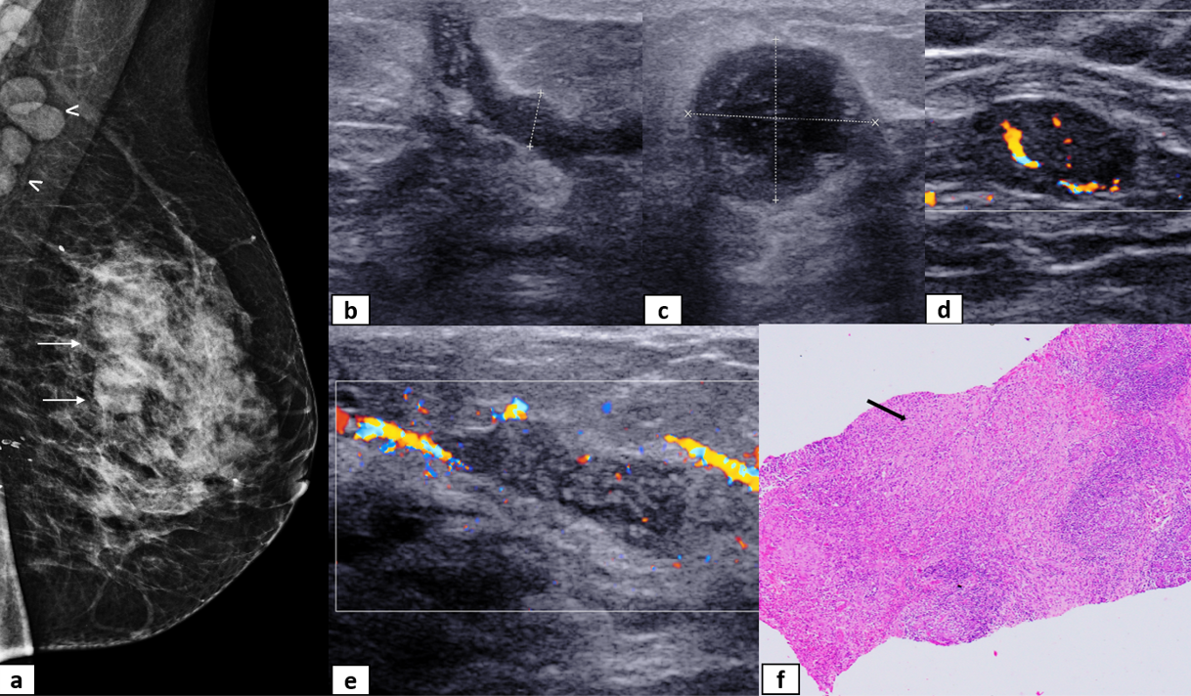

**Figure 1. Idiopathic granulomatous mastitis in a 45-year-old female with a history of breast abscess drainage 1 year back:** Mediolateral oblique (MLO) view of mammogram (a) shows equal density obscured masses in the breast (white arrows) and pathological right axillary lymph nodes (arrowheads). B-mode and colour Doppler ultrasound images show irregular fluid-filled channels, sinus tracts extending to the skin (b), abscess collection (c), axillary lymph node with lost fatty hilum (d) and perilesional hypervascularity (e). In view of persistent complaints, the patient was assigned the BI-RADS 4 category and underwent reassessment with vacuum-assisted biopsy to rule out underlying malignancy. The histopathological evaluation of core needle biopsy depicted epithelioid cell granulomas (Black arrow) & dense lympho-plasmacytic inflammatory infiltrate as seen in figure f.

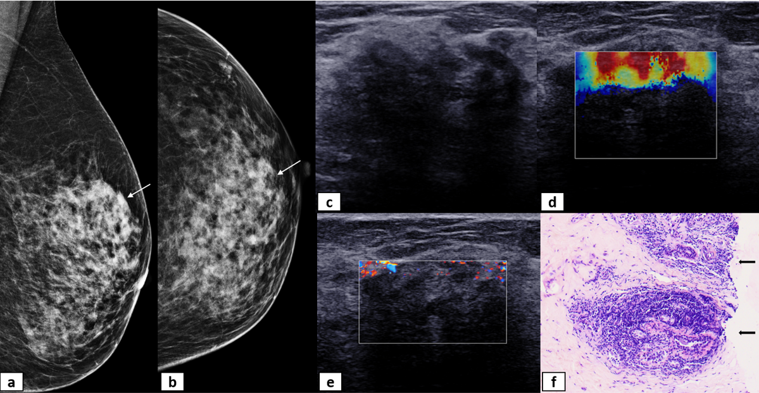

**Figure 2. Diabetic mastopathy in a 50-year-old female presenting with a left breast lump:** High density irregular mass with obscured margins is seen in the mediolateral oblique (MLO) and craniocaudal (CC) views of mammogram (white arrows in a & b). It corresponds to an irregular parallel hypoechoic mass with posterior shadowing on ultrasound (c), hard on shear wave elastography (d), demonstrating mild peripheral vascularity (e), categorized as BI-RADS 4 B. Hematoxylin and Eosin stain of biopsy specimen shows dense lymphocytic infiltrate around terminal duct lobular unit with destruction of acini (black arrows in figure f). Because of the discordant biopsy results, a review of the clinical and radiological parameters was performed. Keeping in mind the patient’s history of diabetes, follow-up with conservative management was suggested, which showed resolution of the mass.

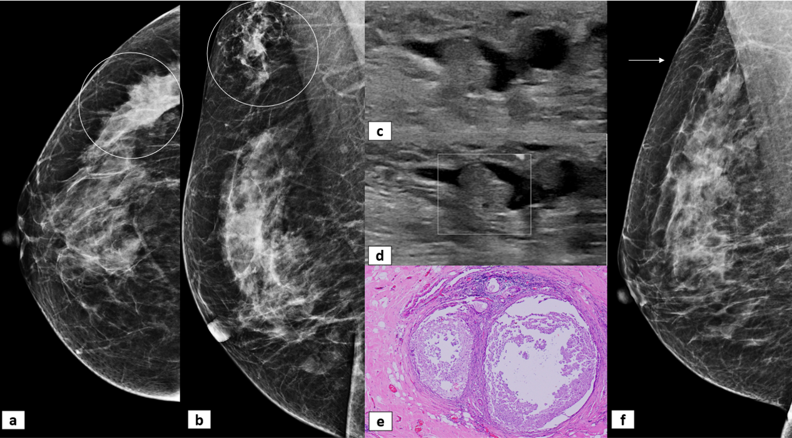

**Figure 3. Periductal mastitis in a 31-year-old female with complaints of cheesy right breast discharge.** Focal asymmetry and architectural distortion are seen in the upper outer quadrant of the breast on mammogram (encircled in a and b). Ultrasound showed dilated ducts with internal isoechoic contents (c–d) that were mobile on probe compression and showed no internal vascularity. The possibility of intraductal papillary neoplasms was kept for consideration, and BI-RADS category 4A was assigned. Histopathological examination of the biopsy specimen showed dilated ducts with intraluminal secretions, periductal fibrosis, and chronic inflammation (e). MDT review with adequate clinical profile was undertaken, and the findings were considered concordant; the follow-up mammogram three months after treatment showed complete resolution (f).

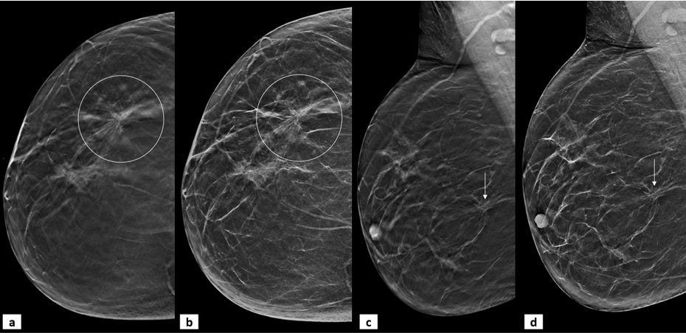

**Figure 4. Complex sclerosing lesion in the screening mammogram of a 63-year-old female.** Architectural distortion with central lucency is seen in the lower outer quadrant on craniocaudal (circled in a and b) and mediolateral oblique (arrows in c and d) views of tomosynthesis (a and c) and synthesized mammograms (b and d). An initial BI-RADS assessment of 4B was considered for the finding. As the size was > 1 cm, image-guided biopsy was undertaken, which revealed a complex sclerosing lesion that was considered concordant on review of the clinic-radio-pathological correlation.

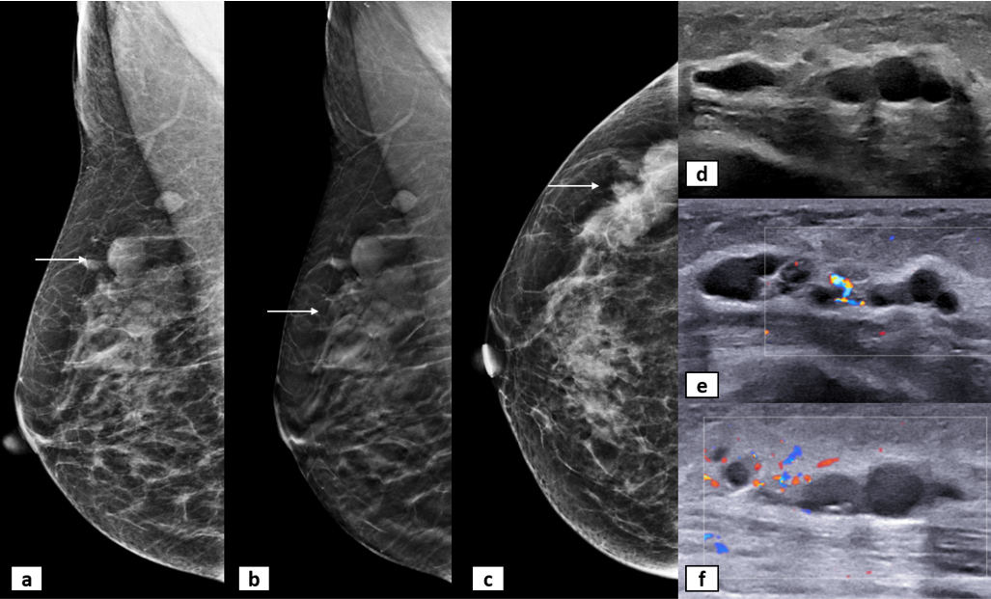

**Figure 5. Lymphatic malformation in a 20-year-old female with a right breast lump since childhood.** Multiple equal-density masses, a few circumscribed and a few with obscured margins, are seen on the MLO, DBT, and CC views of the mammogram (white arrows in a, b, c). They correspond to an irregular parallel contiguous anechoic cystic space, septations, posterior enhancement, and no internal vascularity (d–f). The findings represented non-mass features on USG with ductal changes (BI-RADS 4B B); however, biopsy confirmed them as lymphatic channels and on MDT review, reassessment with repeat USG was performed with a conclusion of concordance.

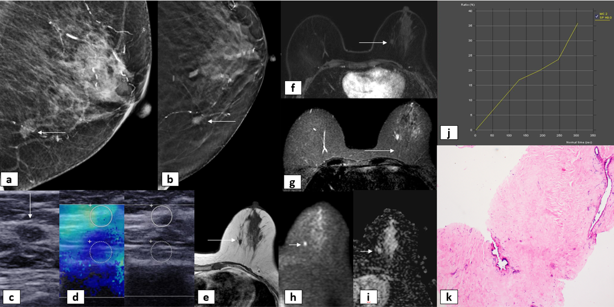

**Figure 6. Sclerosing fibroadenoma in a 70-year-old female, detected during a screening mammogram.** An equal density mass with spiculated margins is seen in the lower outer quadrant on mammogram (white arrows in a & b), categorized as BI-RADS 4C. Corresponding parallel hypoechoic mass with calcific foci and microlobulated margins is seen on ultrasound (c), with intermediate stiffness on elastography (d). Histopathological examination proved it to be a sclerosing fibroadenoma with dense sclerosis around the glands (k). Due to the discordance, MRI was subsequently performed, which showed it as T1 hypointense (e), STIR (g) hyperintense mass with T2 shine through on DWI (h) and ADC(i), delayed enhancement and type I curve (f & j); with final MDT decision as downgrading of BI-RADS category.

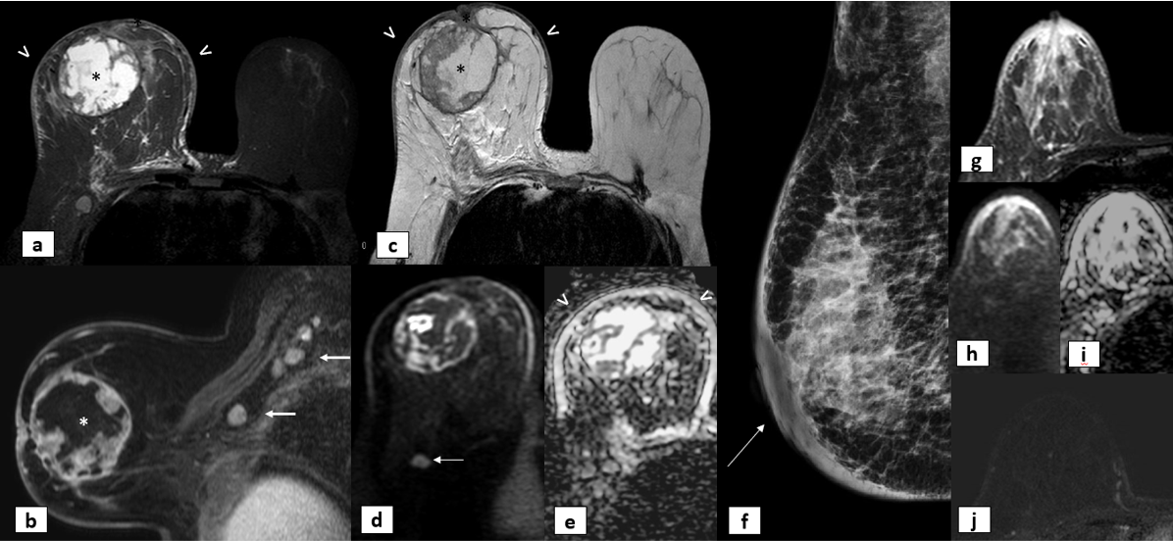

**Figure 7. Inflammatory breast carcinoma in a 49-year-old female with swelling, redness, and peau d’orange appearance of the right breast.** A large necrotic mass with trabecular extension to the nipple (asterisk) is seen in the right breast (a–d), with surrounding inflammatory edema and skin thickening (arrowheads) in the STIR, T2, and ADC images (a, c, and d, respectively). Heterogeneous peripheral enhancement is observed in the mass (asterisk in b), with metastatic enhancing axillary nodes (white arrows in b). Diffusion restriction is observed in the solid component of the mass and the axillary node (arrow in d). BI-RADS category 5 was given on imaging, and it was later proven to be an inflammatory breast carcinoma on biopsy.

A different patient with SLE who presented with unilateral breast enlargement due to congestive heart disease and dependent edema mimicking inflammatory breast carcinoma (f–j) had diffuse skin and trabecular thickening, seen in the MLO view of the mammogram (arrow in f). In view of inconclusive conventional imaging, subsequently performed MRI showed diffuse STIR hyperintensity (g) and T2 shine through on DWI and ADC (h & i), and no abnormal enhancement (h)- considered as mastitis (BI-RADS category 3 was assigned with re-evaluation if no improvement is seen on conservative line of management. The swelling reduced with medical management, confirming the diagnosis.

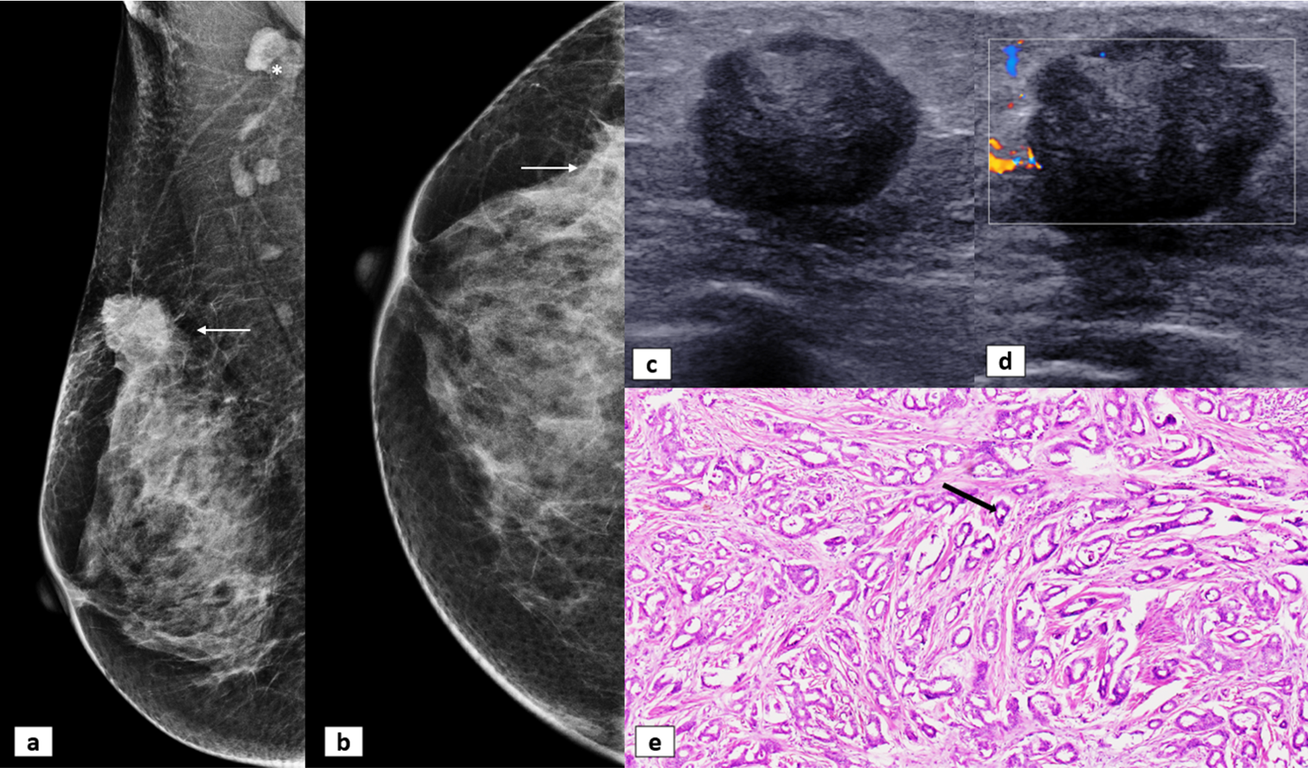

**Figure 8. Tubular carcinoma in a 50-year-old female with a right breast lump.** A high-density lobulated mass with spiculations and surrounding architectural distortion is seen in the upper outer quadrant of the MLO (arrow in a). It is partially visualized in the CC view (arrow in b). One suspicious axillary lymph node was also observed (asterisk in a). Ultrasound correlation showed a parallel hypoechoic mass with microlobulated margins (c and d). The mass was categorized as BI-RADS 4B . Histopathological examination (e) showed well-formed tubules (black arrow), devoid of myoepithelial cells and an angulated appearance of glands consistent with tubular carcinoma. MDT reassessment was targeted at the occurrence of uncommon malignancy and to decide further management.

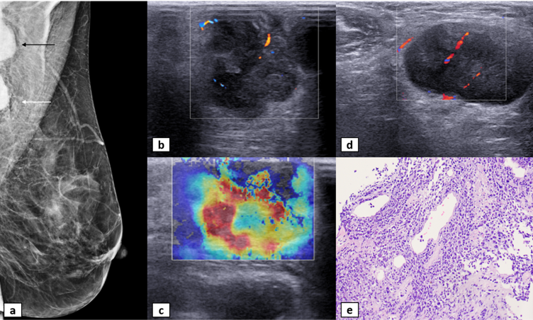

**Figure 9. Neuroendocrine carcinoma in a 52-year-old female with a left breast and axillary lump.** Two high-density masses with circumscribed margins in the axillary tail (mass, white arrow) and right axilla (node, black arrow), seen partially on the MLO view (a). US shows a heterogeneous hypoechoic mass with hyperechoic areas within, reaching up to the skin, with internal vascularity (b) and hardness on elastography (c). An associated metastatic oval homogeneous right axillary node with cortical vascularity is shown in (d). BI-RADS category 4C was given. Histopathological examination showing numerous hyperchromatic nuclei with scant cytoplasm (e), proven to be neuroendocrine carcinoma. In view of unusual malignancy of the breast, reassessment was considered for clinic-pathological correlation and deciding on further lines of management.

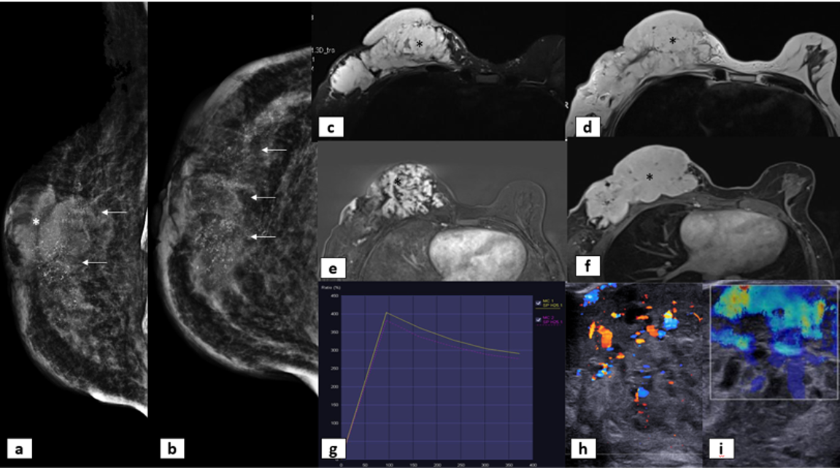

**Figure 10. Hemangioendothelioma in a 40-year-old female with a right breast lump.** MLO and CC views of mammogram show an irregular mass (asterisk in a) with obscured margins, associated skin thickening, and fine pleomorphic microcalcifications (arrows in a and b) in the central quadrant.On MRI, there is a large STIR (c) and T2 hyperintense (d) mass infiltrating the skin (asterisks) in the right breast, with significant post-contrast enhancement (e & f), showing rapid enhancement and washout (type III curve in g). Ultrasound shows multiple cystic spaces and vascular channels within the mass (h), which appears intermediate in stiffness on elastography (i). BI-RADS category 4B was given on the initial assessment, and biopsy revealed a hemangioendothelioma. The imaging underwent reassessment with pathological and clinical profiles to establish concordance and rule out any sarcomatous component.

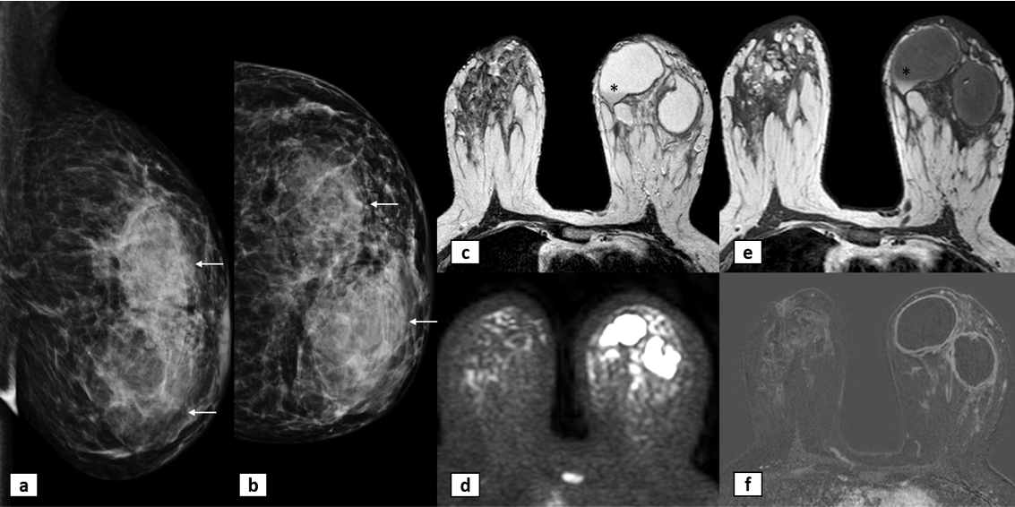

**Figure 11. Hyperprolactinemia induced galactoceles.** Mammogram of a young female receiving treatment for prolactinoma shows two equal-density masses with obscured margins (a and b). Ultrasound (not shown) revealed cystic lesions with dense internal echoes, and internal solid components could not be confidently ruled out. Hence, clinic-radiological reassessment/discussion was performed for evaluation with MRI. On MRI, they are filled with fluid signal intensity with T2 hypointense (c) and T1 hyperintense (e), fat-fluid level (asterisks). Diffusion hyperintensity (d) was seen due to T2 shine-through. Peripheral enhancement (f) is seen post-contrast. Finally, a combined BI-RADS category 2 was assigned. Aspiration of fluid from the cystic lesions proved them to be galactoceles.

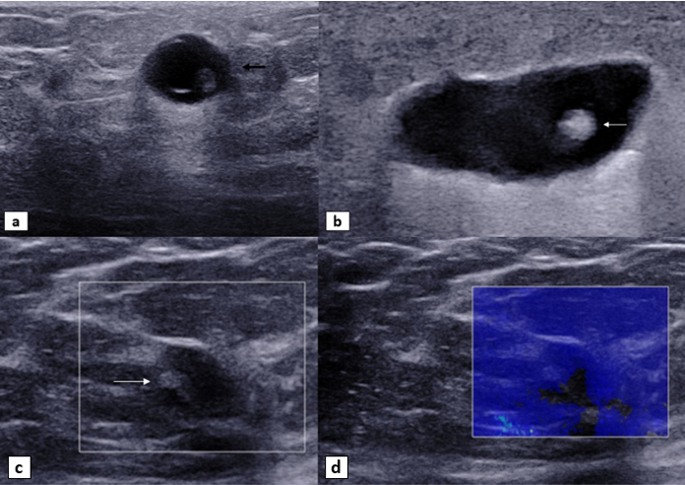

**Figure 12. Cysticercosis in a 20-year-old female with a right breast lump at different time points.** USG shows an anechoic cyst with an eccentric echogenic nodule and a surrounding anechoic fluid collection. USG one month later shows disappearance of the cyst wall, with the cyst merging into the collection that has increased in size. BI-RADS category 4A was assigned on initial imaging; however, biopsy revealed scolex and fragments of cyst walls, suggesting the diagnosis of cysticercosis. US done six months post-treatment reveals an irregular collapsed cyst with eccentric echogenic scolex (arrow in C), which appears soft on elastography (D).

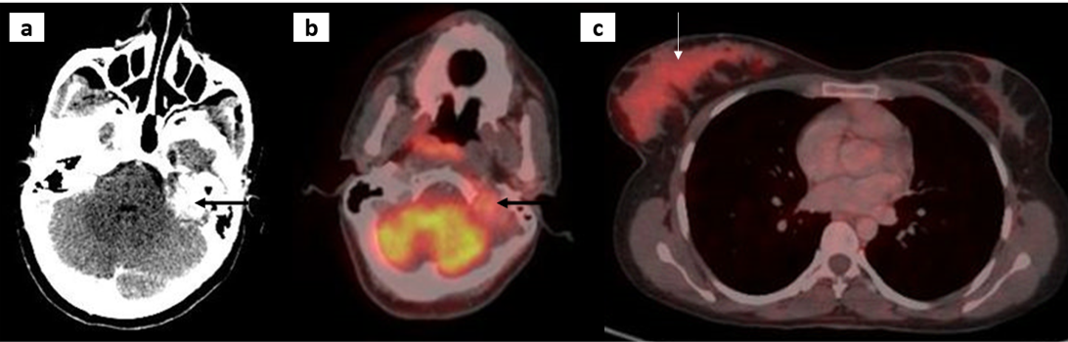

**Figure 13. Asymmetrical PET uptake in the right breast of a 28-year-old female:** (a) CECT head performed for left-sided tinnitus, sensorineural hearing loss, and hemifacial weakness showing an intensely enhancing left petrous apex mass; whole-body FDG-PET/CT showing uptake in the petrous apex mass (b). In addition, there was diffuse intense uptake in the right breast (c), which was enlarged compared to the contralateral side. No mass could be identified on other imaging modalities, and she underwent punch biopsy to rule out inflammatory breast carcinoma with petrous metastasis (Initial BI-RADS assessment of category 4), which came out to be negative for malignancy. To rule out false-positive results on FDG-PET/CT during lactation, the patient was probed regarding nursing practices. She admitted to feeding from the right breast only as per her infant’s preference, which explained the asymmetric FDG-PET uptake during lactation. The petrous mass was further evaluated with MRI (not available), and a diagnosis of glomus jugulare was considered.